**Lab Sessional 1**

Solution

**COMSATS University Islamabad**

Sahiwal Campus



**Usama Sarwar**

FA17-BS(CS)-090-B

**Mr Kashif**

EMO

April 8, 2021

Table of Contents

1. Lab Report 1

1.1 Screenshoots 1

1.2 Conclusion 2

Lab Sessional-1 Examination Spring-2021

Solution

# Lab Report

In this report we find the voltage $V_{°}$ from proteus software.

Table . Proteus Results

|  |  |  |
| --- | --- | --- |
| $$V_{1}$$ | $$V_{2}$$ | $$V_{°}$$ |
| 9V | 3V | 6V |
| 11V | 7V | 9V |
| 12V | 8V | 10V |

## Screenshoots

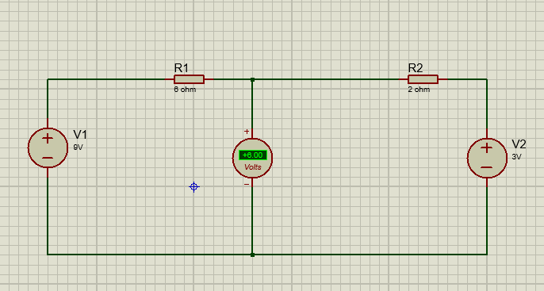

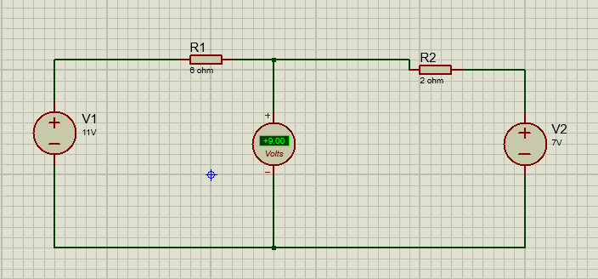

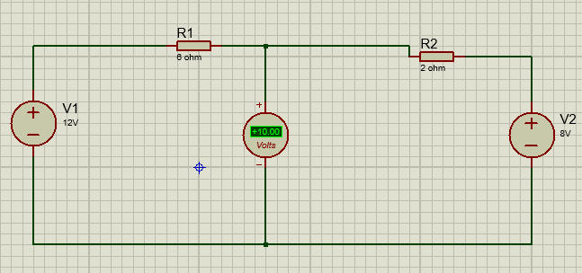

## Conclusion

Thus we find the value of $V_{°}$ by Proteus Software for the different variantions in the value of $V_{1}$ and $V_{2}$.